Coal Pit Headwall
  - Cindi Roller
  - Kati Lewis
  - English 2010
  - 7-26-2011

Wasatch Backcountry

Lone Peak Wilderness
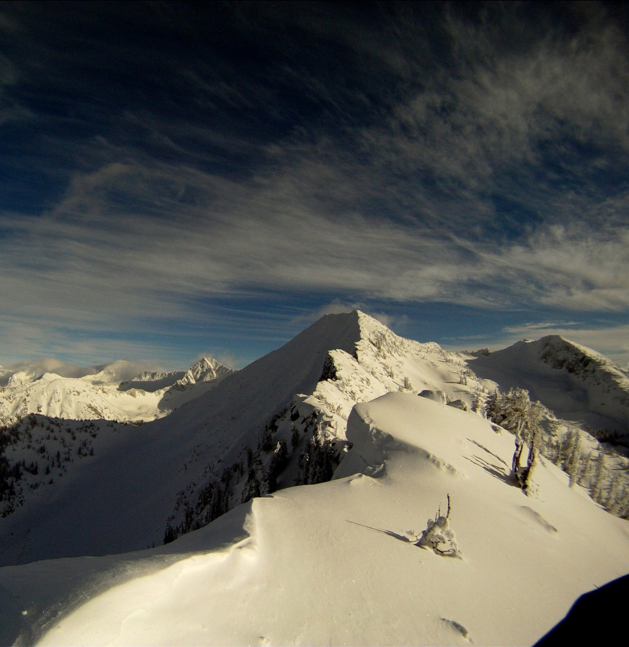
Photography: Zach Grant

I am reviewing a splitboard mountaineering tour I went on last spring. Splitboard mountaineering tours have certain elements that rank them on the totem pole o’ touring. The very best tours include: Esthetic quality, difficulty, produce adrenaline, and the snow needs to be quality deep powder. Climbing up and riding down Coal Pit Headwall was always looming somewhere near the top of my hit list because it usually possesses all of these qualities.
Zach told me that Him, Mark, Alecs, and Justin where getting up at 4:00 am to summit this incredible line. It only took a split second to start packing my gear. I got all my normal stuff together: Split board, skins, bindings, poles, transceiver, probe, shovel, food, water. Then I got my axe and crampons, it is a special moment when I get to take those off the shelf, it is when I know I’m in for an awesome day in the back country.
Coal Pit is kind of a powder island because it is a beautiful untouched headwall that is surrounded by, not particularly easy ways, of getting there. One of these options is by starting from White Pine. You climb up and over all the drainages white pine, red pine, may bird and finally get to hogum but then you still have to go straight up the Hypodermic needle. The hypodermic needle got its name because it pierces through a near vertical band of cliffs like a tube, hence Hypodermic needle.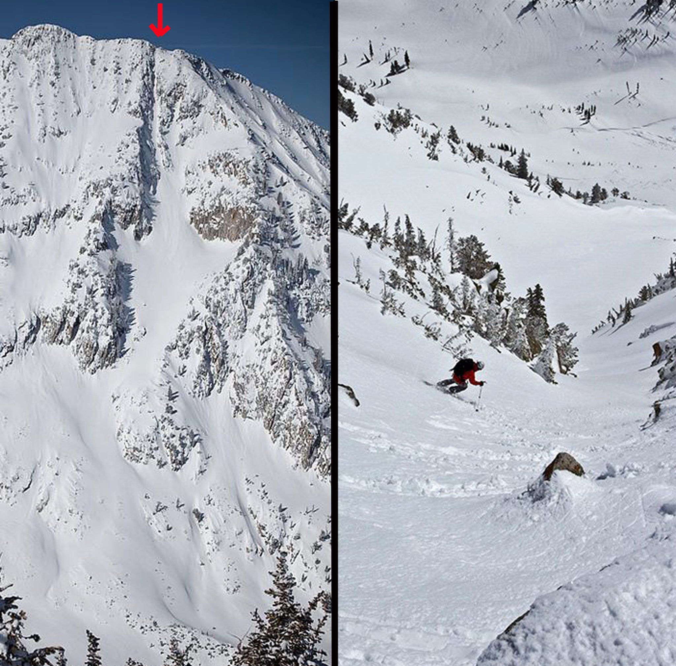
Photography: Mark Hammond left/Alecs Barton right
Mark Hammod Dropping into the Hypodermic Needle with our accent ridge and Coal Pit on the right

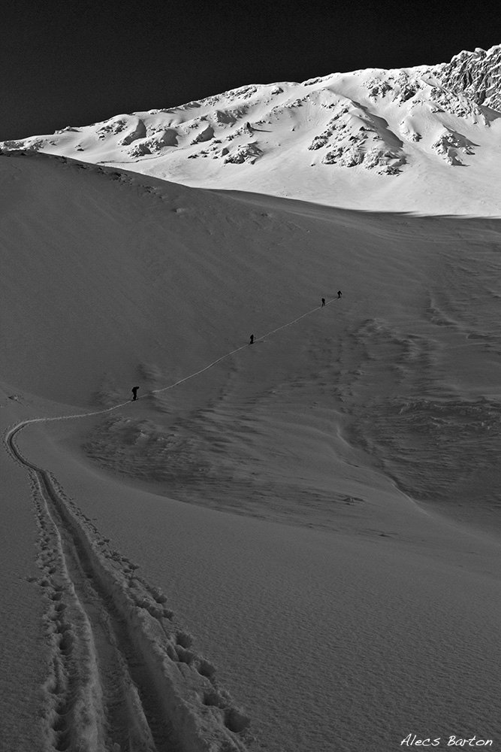
Another way is to do a valley start from Bells Canyon, climb pie in the sky traverse a high consequence ridge to climb the western ridge to the summit of Coal Pit. (This is where the first photo was taken.)There are also numerous other ways, but Mark had something else in mind. Out of true Wasatch backcountry experience Mark had done some recon, and decided why not just go straight up it! We started off the side of the temple quarry trail where the bridge had been washed out the previous spring by very high running melt off. We heard Justin and Alecs fall in the river somewhere off in the darkness, trying to cross it going rock to rock. Zach and I decided to look elsewhere; we found a down log covered in freshly fallen snow. You could try to walk it but risk the chance of falling 5 feet to an icy river or you could straddle and scoot it. After just recently being influenced by the Man vs. Wild episode we watched the night before Zach and I tried the straddle and scoot. This was particularly awkward because we had to hold our skis together and our poles all while trying to scoot across the slippery snow covered log. Finally we both made it and the first barrier to our powder island was put behind us. We skinned up what is a small stream in the winter and a major tributary to little cottonwood in the summer; shortly after we reached coal pit’s water fall. We were very relieved to see it was mostly frozen over and so we got out the crampons and ice axes and climbed up and around it. The exposure of the vertical climb felt good and got our, still sleeping, adrenaline pumping; it was a nice way to start this beautiful day.
Coal Pit drainage is a spectacular sight to see. You are completely engulfed in steepness and because that night had given us freshly fallen snow, it was steep freshies all around. Because of the 360 towering walls we didn’t get any early morning sun until we where almost to the ridge that divides Hogum and Coal pit. As the sun crept over the ridge I remember bolting for the sun line so I could get the warmth on my ice cold face. Once we all crossed over into the sun there was an unspoken sigh of relief from the cold dark wee morning hours.
The ridge didn’t look like too much technical climbing when standing under it but I noticed the over-hanging cornices all the way up. I was glad to be there as early as we where that morning because it was April 27th and that late in the spring it has potential to heat up significantly. Along the way we skirted around the cornices that had the potential of being a platform of death, and gained more and more of the ridge.
Riders Left to right: Zach Grant, Cindi Lou Grant, Mark Hammond, Justin.
Photography: Alecs Barton
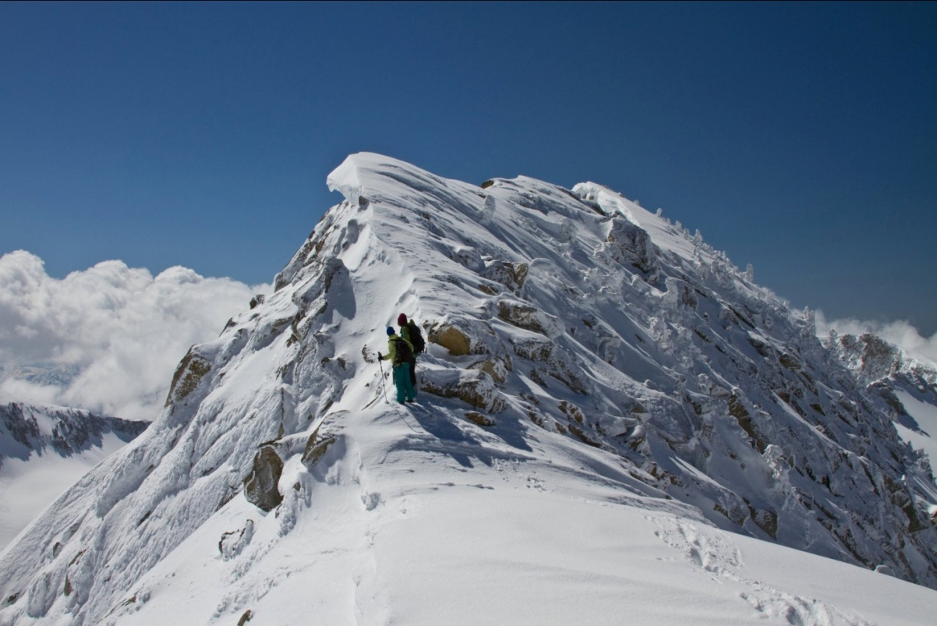
Mark and Alecs where ahead of me and Mark just seemed to glide up ridge without resistance. I decided I was going to keep my skins on and that determination stuck with me. As I followed tight, steep, and small switchbacks to the summit there was one kick turn coming up that changed the way I experienced fear. It was the way that I thought about it that made the experience happen. When I got to it I let the fear take over and I slipped. My knee thudded onto my ski and I scrambled franticly trying to drill my poles and fingers into the snow in an effort to keep my position on the ridge. If I fell forward I would fall over a 200ft cliff into the Hypodermic needle and not stop falling for 2000ft when I arrived at the Hogum valley floor. If I fell backward I would get thrown over a 50 ft cliff and get washed all the way down to the bottom of coal pit headwall. And so I froze. It wasn’t like any type of freezing I had experienced before. I literally couldn’t move for about 10 seconds and it felt like 10 minutes. When I finally started to shake I went to get up. It took me two tries and after the first failed attempt, I drew all the focus and drive left in me and stood up. Just those 10 seconds of real fear changed my composition completely. I was shaken, sweating, and the butterflies that had overrun my stomach decided to stick around for awhile. But really it wasn’t that significant of a fall. It was my perception of that fall that created its meaningfulness. The moments following where some of the best! I gained the summit, and euphoria kicked in. All those butter-flies came out of my stomach and went under my feet, I was floating!
Zach Grant & Cindi Lou Grant
Photography: Mark Hammond

Then after that huge range of feeling I really felt alive and I got to ride Coal Pit headwall as a reward. We split parties at the top, Mark and Justine where going for the Hypodermic Needle and Alces, Zach and I were going for the headwall. We all had been spotting our lines from the bottom and where gunning for them. That was one of the nice things about going straight up your line is that you then get to see it in its current state only hours before slashing down it.
The line I had selected looked like an opening in the cornice dead center on the ridge. As I strapped in and looked over I could see that it was really a small drop. Normally I would have thought twice about dropping a cornice into a 5,000ft line but today I felt good and wanted to do it. Zach spotted me and I dropped in. Dropping this 20 ft cornice quickly felt bigger because of its long steep landing. The sluff of last night’s snow quickly spilt out of my landing strait down the fall line and so I diverted to a higher island of safety. After that it was all smooth, making powder wiggles down all 5,000 feet of Coal Pit! These turns are what I live for and that is the reason I will continue to climb mountains, it is at the top of my lives to do list!
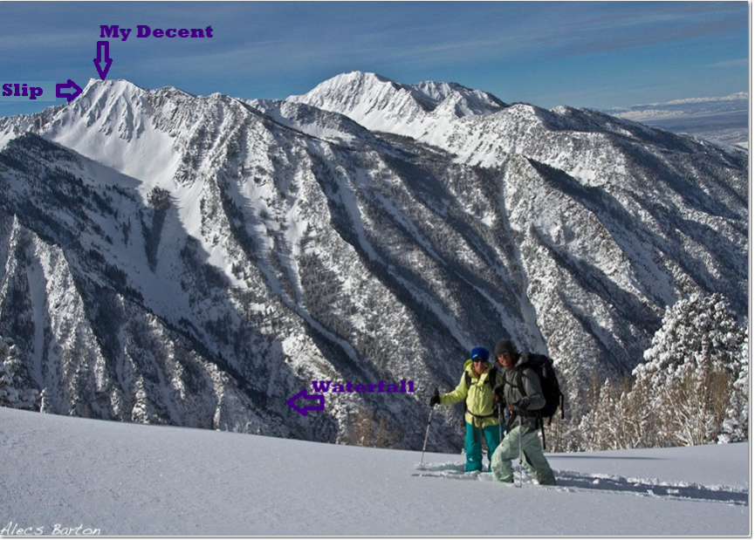

Cindi Lou Grant & Zach Grant
Photography: Alecs Barton

Works Cited
Barton, Alecs. Climbing to the Sun. 04/27/2011.Photography.
The Needle. 03/15/2010 & 04/27/2011. Photography.
Cindi and Zach on TheRidge to Twin Peaks. 04/04/2011. Photography.
Grant, Zach. Coal Pit Head Wall From the Top of Pie In The Sky. 02/14/2011. Photography.
Hammond, Mark. Looking Down the Needle. 04/27/2011 Photography.
Add touring books

